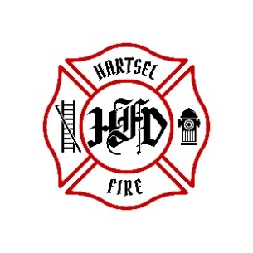
HARTSEL FIRE PROTECTION DISTRICT
PENSION BOARD MEETING

January 16, 2026

- CALL TO ORDER:

2. APPROVAL OF AGENDA:

3. APPROVAL OF PENSION MINUTES DATED: October 10, 2025

4. OLD BUSINESS:
- 3rd Quarter 2025 FPPA Allocation Report

5. NEW BUSINESS:

6. ADJOURNMENT:

POSTED 1/7/2026 @ H.F.P.D. HEADQUARTERS, WEBSITE WWW.HARTSELFIRE.ORG

