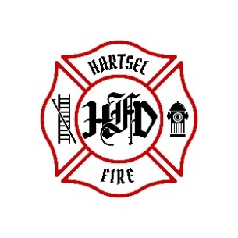
HARTSEL FIRE PROTECTION DISTRICT
BOARD MEETING AGENDA

January 16, 2026

- CALL TO ORDER:

- PLEDGE OF ALLEGANCE

- APPROVAL OF AGENDA:

- CITIZENS COMMENTS / GUEST SPEAKERS: (Limit to 3 minutes per speaker)

- APPROVAL OF MINUTES DATED: December 12, 2025

- BOARD CONCERNS / COMMENTS:

- FINANCIALS:
  - Accept Financials
  - Approve Bills
  - Approve Fund Transfers
  - Sign Documents / Checks

- FACILITY EQUIPMENT REPORT

- CHIEF’S REPORT:
  - Calls to Date: 2025 ________, 2026 _______
  - Impact Fees to Date: 2025_______, 2026_______

- OLD BUSINESS:

- NEW BUSINESS:

- OTHER:

- ADJOURNMENT:

POSTED 1/7/2022 @ H.F.P.D. HEADQUARTERS, WEBSITE WWW.HARTSELFIRE.ORG

