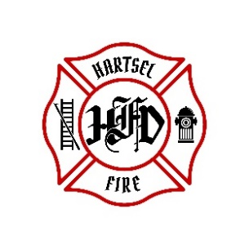

**HARTSEL FIRE PROTECTION DISTRICT**

**PENSION BOARD MEETING**

**April 11, 2025**

1. **CALL TO ORDER:**

**2. APPROVAL OF AGENDA:**

**3. APPROVAL OF PENSION MINUTES DATED: January 17, 2025**

**4. SIGN DOCUMENTS:**

**5. OLD BUSINESS:**

1. **4th Quarter 2024 FPPA Allocation Report**

**6. NEW BUSINESS:**

1. **New Member**

**7. ADJOURNMENT:**

**POSTED 4/7/2025 @ H.F.P.D. HEADQUARTERS, WEBSITE** [**WWW.HARTSELFIRE.ORG**](http://WWW.HARTSELFIRE.ORG)