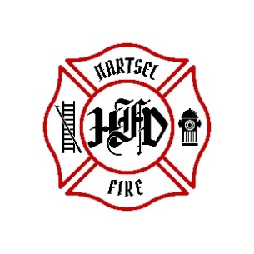
HARTSEL FIRE PROTECTION DISTRICT
PENSION BOARD MEETING

October 10, 2025

- CALL TO ORDER:

2. APPROVAL OF AGENDA:

3. APPROVAL OF PENSION MINUTES DATED: July 11, 2025

4. OLD BUSINESS:
- 2nd Quarter 2025 FPPA Allocation Report

5. NEW BUSINESS:

6. ADJOURNMENT:

POSTED 10/1/2025 @ H.F.P.D. HEADQUARTERS, WEBSITE WWW.HARTSELFIRE.ORG

