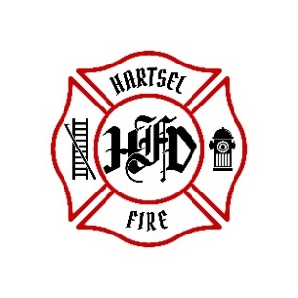
Hartsel Fire Protection District
131 Elm Street
Hartsel, Colorado 80449

NOTICE OF PENSION BOARD MEETING AND AGENDA

WHEN: April17, 2026
TIME: 9:00 AM
PLACE: HFPD Headquarters, 131 Elm Street, Hartsel, CO

- CALL TO ORDER:
- APPROVAL OF AGENDA:
- APPROVAL OF PENSION MINUTES DATED: January 16, 2026
- OLD BUSINESS:
a. 4th Quarter 2025 FPPA Allocation Report
- NEW BUSINESS:
- ADJOURNMENT:

POSTED 4/7/2026 @ H.F.P.D. HEADQUARTERS, WEBSITE WWW.HARTSELFIRE.ORG

