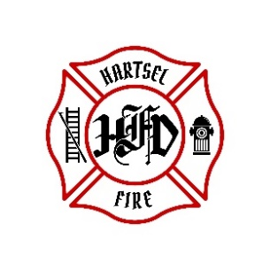

**HARTSEL FIRE PROTECTION DISTRICT**

**BOARD MEETING AGENDA**

**April 12th, 2024**

1. **CALL TO ORDER:**
2. **PLEDGE OF ALLEGANCE**
3. **APPROVAL OF AGENDA:**
4. **CITIZENS COMMENTS / GUEST SPEAKERS:**
5. **APPROVAL OF MINUTES DATED: March 15, 2024**
6. **BOARD CONCERNS / COMMENTS:**
7. **FINANCIALS:**
   1. **Accept Financials**
   2. **Approve Bills**
   3. **Approve Fund Transfers**
   4. **Sign Documents / Checks**
8. **FACILITY EQUIPMENT REPORT**
9. **CHIEF’S REPORT:**
   1. **Calls to Date: 2023 ________, 2024 _______**
   2. **Impact Fees to Date: 2023_______, 2024_______**
10. **OLD BUSINESS:**
11. **NEW BUSINESS:**
    1. **Station 6 Design**
    2. **Facility Maintenance Equipment**
    3. **Board Position**
12. **ADJOURNMENT:**

**POSTED 4/4/2024 @ H.F.P.D. HEADQUARTERS, WEBSITE** [**WWW.HARTSELFIRE.ORG**](http://WWW.HARTSELFIRE.ORG)