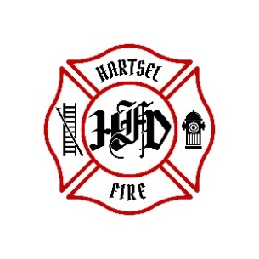
Hartsel Fire Protection District
131 Elm Street
Hartsel, Colorado 80449

NOTICE OF REGULAR BOARD MEETING AND AGENDA

WHEN: March 13, 2026
TIME: 9:00 AM
PLACE: HFPD Headquarters, 131 Elm Street, Hartsel, CO

- CALL TO ORDER:
- PLEDGE OF ALLEGANCE
- APPROVAL OF AGENDA:
- CITIZENS COMMENTS / GUEST SPEAKERS: (See rules below)
- APPROVAL OF MINUTES DATED: February 13, 2026
- BOARD CONCERNS / COMMENTS:
- FINANCIALS:
  - Accept Financials/Bills & Approve Fund Transfers
- FACILITY EQUIPMENT REPORT
- CHIEF’S REPORT:
  - Calls to Date: 2025 ________, 2026 _______
  - Impact Fees to Date: 2025_______, 2026_______
- OLD BUSINESS:
  - Wildland Resiliency Code
  - Burn Facility
- NEW BUSINESS:
- OTHER:
- ADJOURNMENT:

POSTED 3/4/2026 @ H.F.P.D. HEADQUARTERS, WEBSITE WWW.HARTSELFIRE.ORG

*Rules for Public Comment:
1. Each speaker has 3 minutes, unless the Board authorizes additional time. Total time for public comment is 15 minutes. Each person may speak only once. A speaker may not give part of his/her time to another speaker.
2. Only one speaker will be acknowledged at a time. Speakers must begin their comments by stating their name and address.
3. Public comments are not limited to agenda items, but they must be relevant to the District.
4. Speakers are prohibited from engaging in personal attacks, using profanity, or engaging in other conduct that disrupts, disturbs, or otherwise impedes the orderly and efficient conduct of the meeting. Also prohibited are overly long, unduly repetitious, or irrelevant remarks that disrupt, disturb, or otherwise impede a meeting by preventing the Board from accomplishing its business in a reasonably efficient manner.

