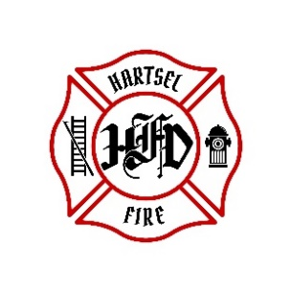

**HARTSEL FIRE PROTECTION DISTRICT**

**BOARD MEETING AGENDA**

**June 16, 2025**

1. **CALL TO ORDER:**
2. **PLEDGE OF ALLEGANCE**
3. **APPROVAL OF AGENDA:**
4. **CITIZENS COMMENTS / GUEST SPEAKERS: (Limit to 3 minutes per speaker)**
5. **APPROVAL OF MINUTES DATED: May 16, 2025**
6. **BOARD CONCERNS / COMMENTS:**
7. **FINANCIALS:**
   1. **Accept Financials**
   2. **Approve Bills**
   3. **Approve Fund Transfers**
   4. **Sign Documents / Checks**
8. **FACILITY EQUIPMENT REPORT**
9. **CHIEF’S REPORT:**
   1. **Calls to Date: 2024 ________, 2025 _______**
   2. **Impact Fees to Date: 2024_______, 2025_______**
10. **OLD BUSINESS:**
    1. **Operational Agreement**
    2. **Dispatch Feasibility Study**
    3. **Accounting Process**
11. **NEW BUSINESS:**
    1. **New Stations**
12. **OTHER:**
13. **ADJOURNMENT:**

**POSTED 6/9/2025 @ H.F.P.D. HEADQUARTERS, WEBSITE** [**WWW.HARTSELFIRE.ORG**](http://WWW.HARTSELFIRE.ORG)